Handout no. 6

|  |  |
| --- | --- |
| **Name** |  |
| **Reg. No** |  |
| **Marks/Grade** |  |

**EXPERIMENT # 6**

**Perform tap-changing in transformers to analyse voltage regularity in power system**

**Objective:**

At the end of this lab session students will be able

* To analyse Power system operations in Power World Simulator.
* To accurately perform tap- changing in transformers for voltage regulation in PWS.

**Introduction:**

**Simulation:**

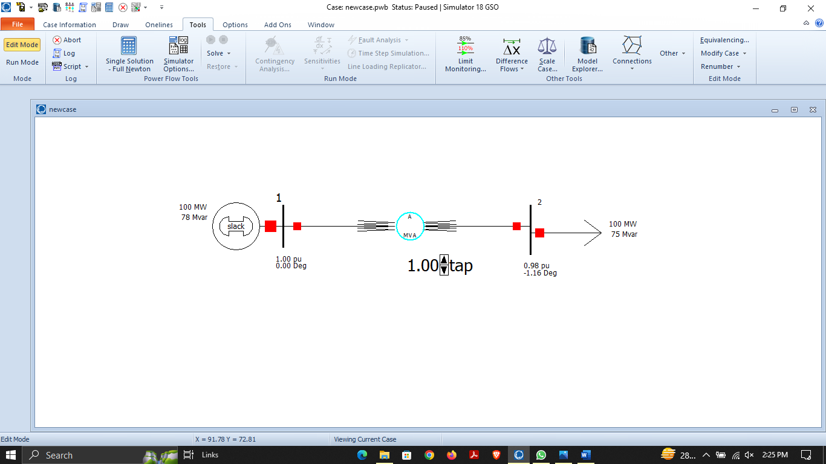

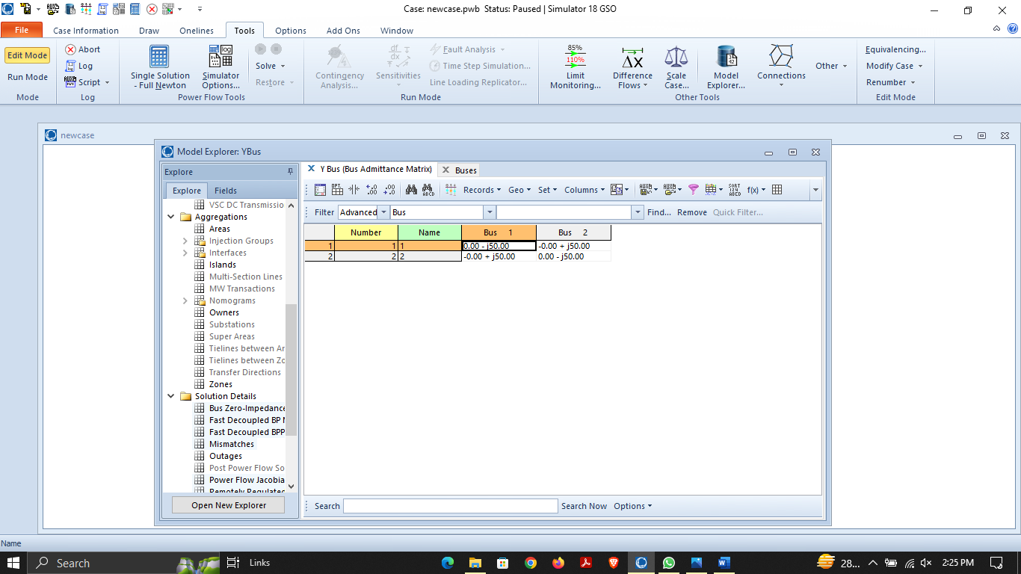

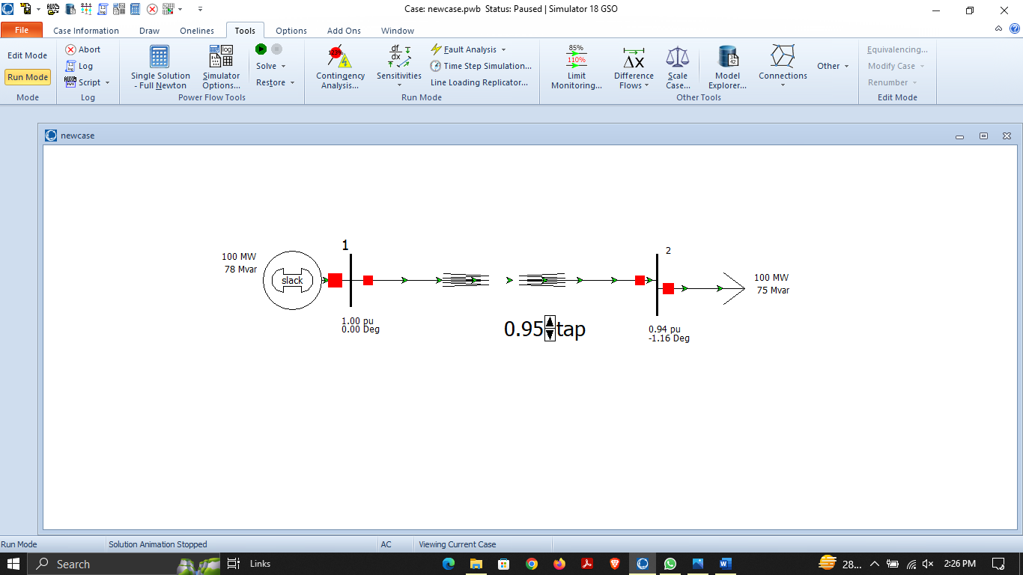

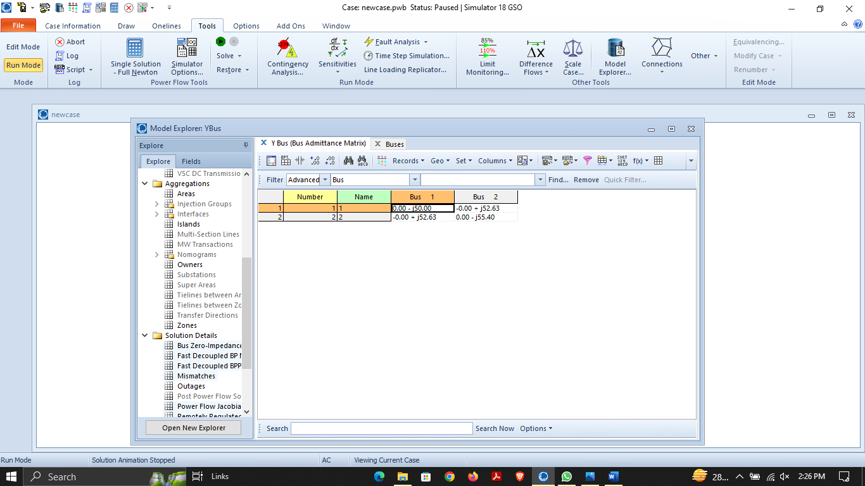

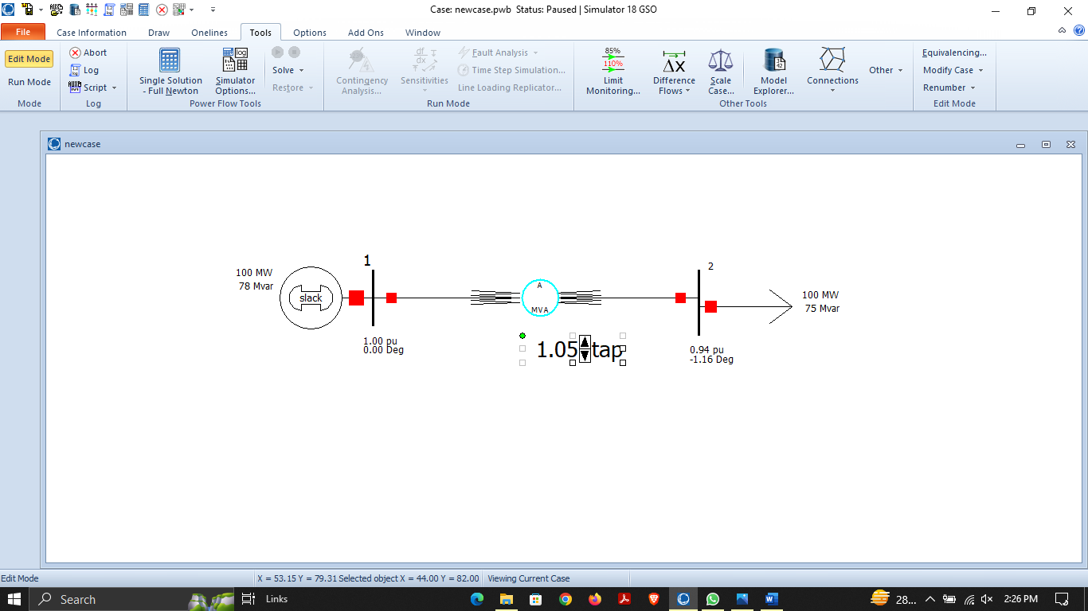

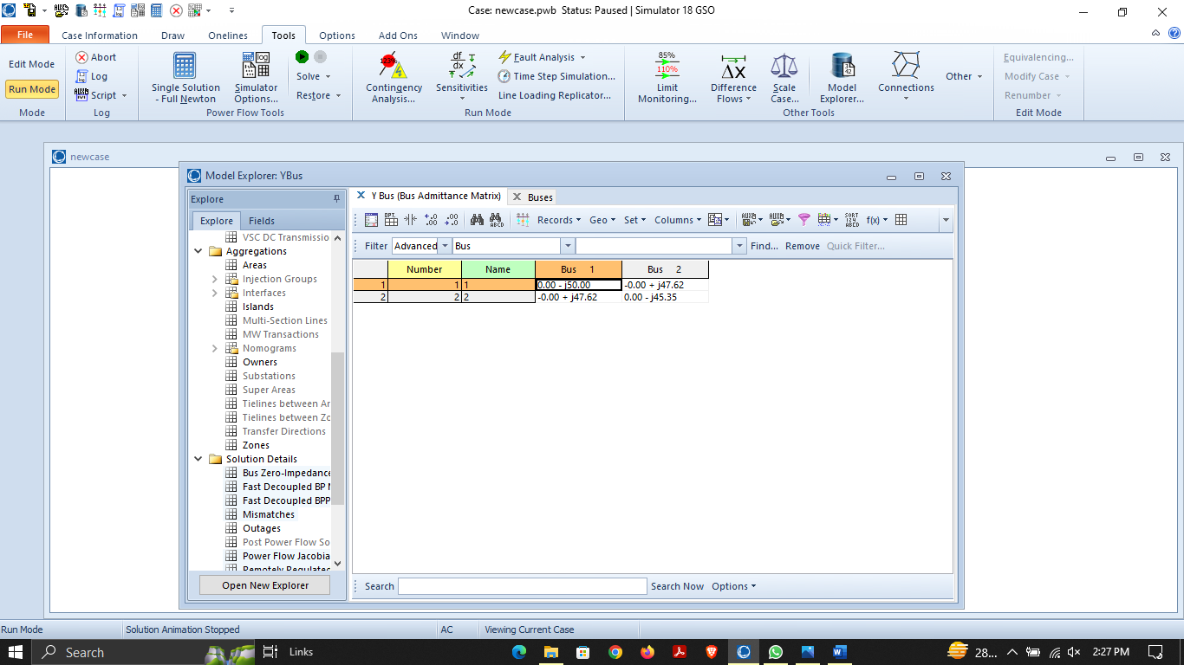

**Mathematical Calculations:**

**Observation and Conclusion:**